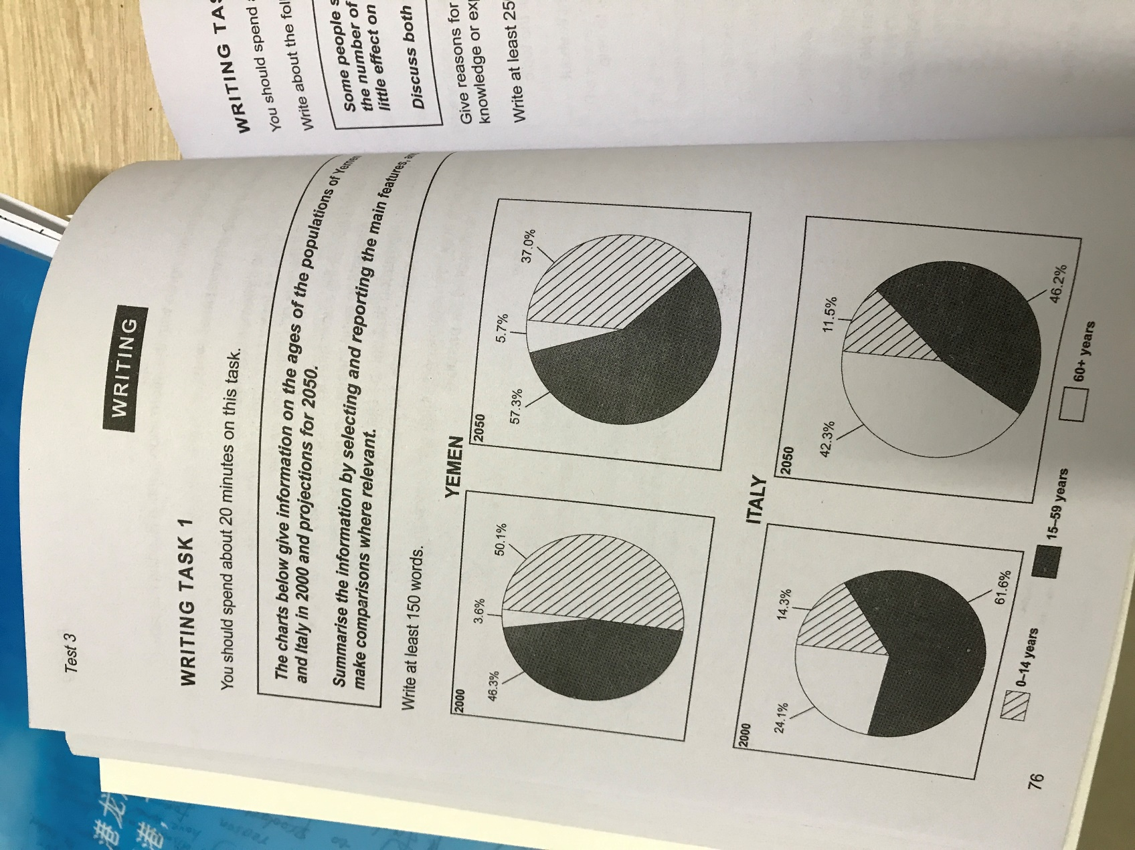

The graph illustrates the data on population ages of Yemen and Italy in 2000 and the prediction in 2050.

The top two graphs show the population changes of Yemen. The percentage of population between the age of 15 and 59 will increase from 46.3% to 57.3%. Take the first place among all instead of population under 14 years old, which will decrease from 50.1% to 37%. The amount of people above 60 years old will also make a slight increase but remain the lowest percentage in all three.

The data of Italy is much different. The population between 15 and 59 will drop significantly by almost 15%, while the number of people older than 60 years old will increase from 24.1% to 42.3%. the population under 14 will also fall unrecognizably by 2.8% to 11.5%. The relative position of each section will not change, although there is a trend could be seen. The population between 15 and 59 is the largest and child under 14 is the fewest.

These two countries are making a completely different change on population distributions.